IOT Based Weather Monitoring System

## Raghu Ram Vadlamudi, Ravipat Ravi Venkata Kiran Kumar , Ranjit Banerjee, Shaik Meer Mohammad

Department of Computer science and Engineering

Apex Institute of technology,chandigarh university,mohali,India

Email: [19BCS4596@cuchd.in](mailto:19BCS4596@cuchd.in),19BCS4624@cuchd.in,19BCS4619@cuchd.in,19BCS4607@cuchd.in

**Abstract:- The IoT Technology provided in this paper is a good option for surveillance the weather data at a particular region and make the data visible anywhere in the world. The idea behind this is Electronic sensors connected to the Public Internet by using IoT technology. The data fetched from the embedded system can be accessible over the Internet from anywhere in the world. In some area, it will be challenging to check and monitor the vital weather parameter through wires and analogue devices during some weather hazards. To resolve this problem here, electronic sensors are used to review and monitor the weather parameters.**

**Keywords: IoT Technology; Weather Monitoring System; Embedded System, Microcontroller, Environment data study**.

I.INTRODUCTION

A weather station is a technology that collects data related to the weather & environment using different electronics sensors. There are two types of weather station, one who is having their sensors and the second type of weather station is where we pull data from the weather station servers. In this project, we are designed by our weather station. We all know that a weather station is not a single device, but it is a combination of many small tools to form a larger system. It contains various sensors and gadgets that work together but in specific ways to transmit proper and accurate data of the weather parameters.

It is quite tricky to uses of WEB server based weather station to non-technical peoples, so we are providing web server-based user interface as well as Android application. We are well known today most mobile units running on Android OS, and many peoples are well known to use the android phone. So, our application is beneficial for such purpose.

This device is all about IoT based Live Weather data Monitoring Using NodemCU ESP8266. We will interface DHT11 Humidity & Temperature Sensor, BMP180 Barometric Pressure Sensor and with NodeMCU ESP8266-12E wi-fi Module.

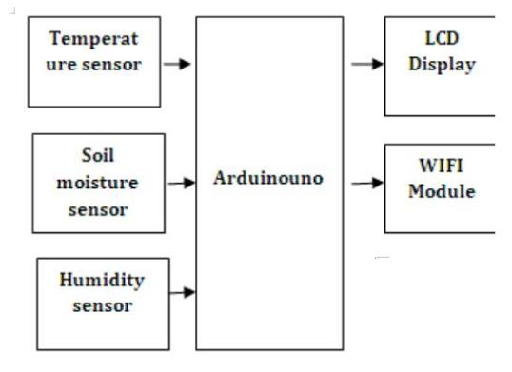

Fig. 1 Block Diagram

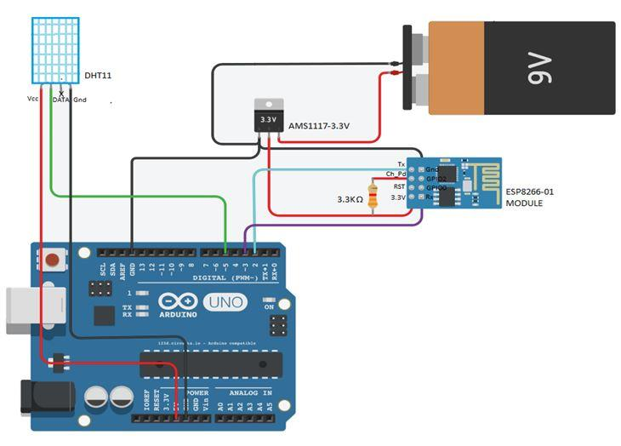

Fig. 2 Circuit Diagram

II. LIERATURE SURVEY

There are possible to make the user-friendly live weather monitoring system using IoT technology. IoT is an Internet of things which capable of transferring data over a network without requiring human interaction [1]

With the development of a cloud-based system, the cloud platform can give better weather availability of data anywhere and anytime. The weather needs easy ways and new techniques for surveillance and management. Monitoring the weather parameter is required to assess the live condition of the weather to takes the right life action according to fetched data from the device. [2]

It is an embedded system which consists of web- enabled smart such as processors, sensors and communication hardware, to fetch, transmit and work on available data they obtained from their weather. The IoT devices sent this processed data to the network gateway, and from there, it will be available to within network. But by designing such a system which also available on public Internet also is make more advantage to human life. [3]

Previously many of IoT based weather monitoring system design used third parties IoT platform such as Thing Speak. But we have designed our cloud-based server because of that anyone can easily access our web-based service or through android app [4].

Through the meteorological system, we can collect data on humidity and Temperature, as well as data on pollution and, taking into account current and previous data, we can graphically modify the results in any system. After reviewing many articles, there are currently far fewer articles that mention monitoring the combination of temperature, lighting and humidity in a small integrated system and have actuators to change these settings. There is a research paper that discussed the monitoring of these three environmental conditions; however, there was no mention of having actuators to modify. Thus, the main idea was to create a system that could detect the main components that make up the climate and be able to predict time without human error. Existing weather forecasting methods were generally based on observed patterns of events, and can be called pattern recognition. For example, one could observe that if the sunset was red and normal, the next day often brought a very nice weather. This experience gathers more than and generations to produce the tradition of the time. However, not all of these predictions are reliable and since then many of them have not been able to withstand rigorous statistical testing. The simplest way to predict time, persistence, depends on today's conditions to predict tomorrow's conditions. This can be a good way to predict weather when it is in a stationary state, such as during the summer in the tropics. This method of forecasting depends on the presence of a stationary weather pattern. It can be useful for both short- and long-range weather forecasts.

III. WORKING

Assemble all system as per circuit diagram. Program the NodeMCU using Arduino IDE. You will get confirmation on your screen once

The NodeMCU is a programable controller which has inbuilt wi-fi module We connect three sensors 1) BMP180 2) DHT11 and 3) Rain Sensor to NodeMCU. By using these three sensors, we can collect the required weather data for monitoring purpose. This pooled data is stream over the Internet to display it or read it from anywhere. After the successfully programmed hardware, the NodeMCU get one IP address. We can browse this IP address from any of WEB browser like Chrome, Firefox, Internet Explorer etc.so we display the required live data which fetched by sensors in beautiful Graphical User Interface format. The weather parameters that we monitor are Temperature, Pressure, Humidity and Rain.

Also, you can check whether data through anywhere using Internet as we hosted this server publicly. We developed an android application for easy access to our weather monitoring system.

IV.PROBLRM FORMULATION

The Problem found in most weather Stations recently all the weather Stations Consists of their Own Data Centre to Access and send the information to Display devices. Each and every data centre needs Crores to build their own data centre in the particular place. IoT Based Weather System acts as Weather Station and it update the Data Centre in Cloud. So, by using IoT Based Weather monitoring System we can solve the cost of equipment problem and also, we can also access the information remotely through internet Devices and Websites.The weather monitoring system provides only the present condition of a particular field which will not provide the exact condition of the particular city or particular place. The main problems in ordinary method were that devices are very much expensive and don’t have that much data measuring accuracy. In case of any divergent there is no such device to give the alert signal about current situation hence it’s very hard to control that kind of abnormality.

Limitations of the existing Weather Monitoring System

a.) Existing weather monitoring systems that are used generally consist of unconventional and heavy machinery that consists of number of moving parts that require constant maintenance and need to be monitored and changed frequently.

b.) Power requirements are one of many major constraints as these instruments are generally sited far from main power supply. This made instruments costly.

c.) Thermometers to measure external Temperature; But accurate is still not updated and continuously needs to be checked regularly for any change in temperature.

d). Data collected by the instruments needs to be manually transferred from the system to a Laptop or computer via a cable.

V.PROPROSED SYSTEM

The main objective of this project is to originate electronic device or network that can capture and restore temperature and humidity and after that send data to the cloud or website for its analysis.Here we can use the Arduino Unoas a microcontroller for the simple brain of the system. When we use the Arduino as a microcontroller, we need a Wi-Fi module to establish your Internet connection. And the DHT sensor, which (digital humidity sensor) can detect differences in temperature, humidity and humidity at a certain location, must be integrated into the system. The sensor continuously monitors temperature changes and sends data to the microcontroller. The microcontroller transfer the data for its storage and visualization to cloud. We can also use IOT platforms such as ThinkSpeak IoT to collect data into the cloud for analysis. This system can then be customized to create good animations such as tweets or phone calls, or turn on a device when the temperature /humidity or other parameters are below a certain threshold.

VI.HARDWARE AND SOFTWARE

IoT Based Weather Monitoring System is required hardware as well as the software needed to implement. The details are given follow.

*Hardware Components:*

The things needed for this project are given below.

1. Nodemcu ESP8266 12E Board

2.BMP180 Pressure Sensor

3.DHT11 Humidity temperature Sensor

1. Rain Sensor FC37
2. Resisitors 2
3. PCB

*Software components:*

1.HTML file library

2.Arduino IDE

3.Pressure Sensor BMP180 Library

4.Humidity Temperature Sensor DHT11 ESP Library.

VII.APPLICATION DETAILS

1)Data are available on the android app.

2)Prior weather alert or weather data can be possible.

3)Useful for the agriculture sector as a system is very cheaper, it can be affordable to Farmer.

4)By making an extensive network of this device, we can fetch real-time data of weather from a different location that can be available for free help purpose.

5)The weather forecasting plays very important role in the field of agriculture.

6)It is also helpful at places like volcano and rain forests.

7)It is quite difficult for a human being to stay for longer time at such places

VIIII.CONCLUSION

By keeping the weather station in thenvironment for monitoring enables self protection (i.e., smart environment) to the environment. To implement this need to use the sensor devices in the environment for collecting the data and analysis. By using sensor devices in the environment, we can bring the environment into real life. Then the collected data and analysis results will be available to the user through the Wi-Fi. The smart way to monitor environment an efficient,

low cost embedded system is presented in this paper. It also sent the sensor parameters to the cloud. This data will be helpful for future analysis and it can be easily shared to

other users also. This model can be expanded to monitor the developing cities and industrial zones for pollution monitoring. To protect the public health from pollution, this model provides an efficient and low cost solution for continuous monitoring of environment.

IX. FUTUTRE SCOPE

The proposed IoT and cloud based weather monitoring system can be further modified to many more

features. We can also add a GPS device in the design so that the location of the surrounding will also be mailed or messaged to the user along with the surrounding parameters,like temperature, humidity, pressure, light intensity etc.We can add various other sensors for measuring various other weather parameters like solar radiation,visibility etc. The system can also be modified such that whenever a message is sent from a particular phone number or email id to the server, all the environmental parameters

can be sent as notification or as a message to mobile phone or email id.Also,this weather monitoring system can be used in smart city projects and many other automation projects.

One can implement a few more sensors and connect it to the satellite as a global feature of this system.

Adding more sensor to monitor other environmental parameters such as CO2,Pressure and Oxigen Sensor

In aircraft, navigation and military there is agreat scope of this real-time system.

It can also be implemented in hospitals or medical institutes for the research & study in “Effect of Weather on Health and Diseases”, hence to provide better precaution alerts.

X. ACKNOWLEDGEMENT

A great deal of work goes into the stage I of final year project that every dedicated engineering student aspires for. However, nothing can compare with the satisfaction one experiences when the expectations and dreams of a student are actually realized in the form of a physical working model. We have several people to thank for having embarked on this beautiful, exciting and arduous journey with us.

. REFERENCES

1. A Study on IoT Approach for Monitoring Water Quality Using MQTT Algorithm, Alfiya Abubaker1, Kavya C R2, Tilju Thomas3, Nikhil Joseph4, Shifana Begum5, 1,2,3,4 Final Year UG Students, Dept. of CSE, Srinivas School Of Engineering, Mangalore
2. IoT Based Water Quality Monitoring System, Mourvika Shirode, Monika Adaling, Jyoti Biradar, Trupti Mate, Department of Electronics & Telecommunication Keystone School of Engineering, Pune, Maharashtra,

India

1. https://internetofthingsagenda.techtarget.com/definition/I nternet-of-Things-IoT
2. Girija C Department of Electronics and Communication, NIEIT, Andreanna Grace ShiresDepartment of Electronics and Communication, NIEIT, Mysuru Internet of Things (IoT) based Weather, International Journal of Engineering Research & Technology (IJERT)
3. Mobile APP & IoT Based Station Weather Station. AUTHOR: K. N. V. SATYANARAYANA, S. R. N. REDDY, K. N. V. SURESH VARMA & P. KANAKA RAJU
4. Arduino Based Weather Monitoring System. AUTHOR: Karthik Krishnamurthi, Suraj Thapa, Lokesh Kothari,

Arun Prakash

1. Internet of Things (IoT) Based Weather Monitoring system, Bulipe Srinivas Rao1, Prof. Dr K. Srinivasa Rao2, Mr N. Ome3, international Journal of Advanced Research in Computer and Communication Engineering, ISO 3297:2007 Certified, Vol. 5, Issue 9, September 2016
2. https://how2electronics.com